Fraud Detection Business Questions and SQL Queries
The fraud banking dataset contains 8,300 transactions, of which 300 duplicate records were identified and removed during cleaning. Data quality was generally good, with missing values below 3% in key attributes. Customer activity is dominated by Gold and Premium segments, while international transactions account for approximately 36% of overall volume. Device, payment channel, merchant, and geographic analyses reveal several areas requiring enhanced fraud monitoring, particularly transactions originating from new devices, Android devices with spelling inconsistencies, and international payment activity.

A. Data Quality & Governance
Q1. Total Transactions
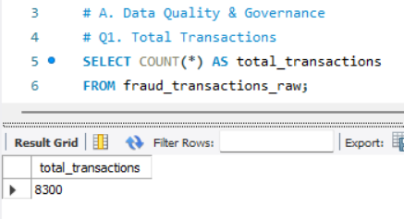
Insight
The dataset contains 8,300 transactions, providing sufficient volume for customer, merchant, fraud, and behavioral analysis.
Recommendation
- Use this as the benchmark transaction volume for future growth analysis.
- Track monthly transaction growth KPIs.

Q2. Duplicate Transactions
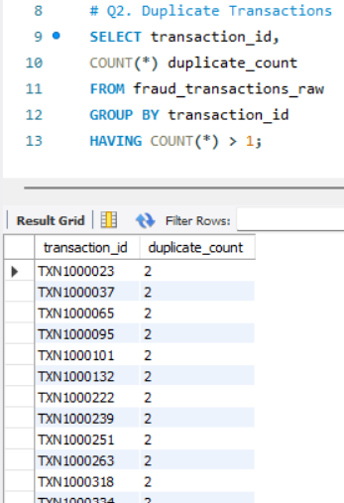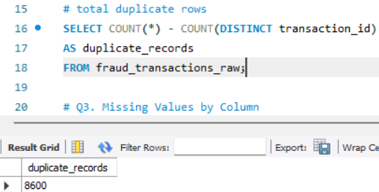
Insight
Approximately 300 duplicate transaction records were detected, indicating data ingestion or ETL issues.
Recommendation
- Implement transaction_id uniqueness constraints.
- Add automated duplicate checks during data loading.

Q3. Missing Values
Insight
Missing values are relatively low:
- Customer City: 2.23%
- Device Type: 2.22%
- Merchant Name: 2.25%
Data quality is acceptable but requires remediation.
Recommendation
- Implement mandatory validation for merchant and device fields.
- Use automated imputation or exception reporting.

Q4. Data Entry Errors
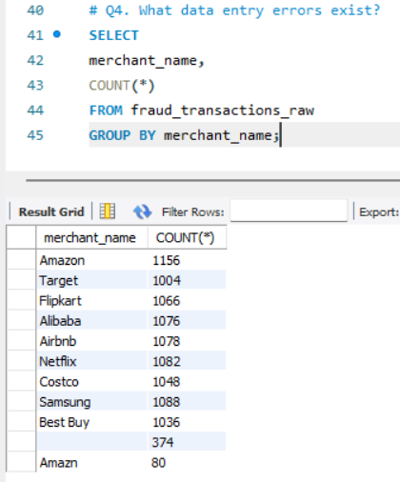
Insight
Merchant spelling variations such as "Amazon" and "Amazn" indicate inconsistent data entry standards.
Recommendation
- Create standardized merchant master tables.
- Apply fuzzy matching and text standardization rules.

Q5. Invalid City-Country Combinations
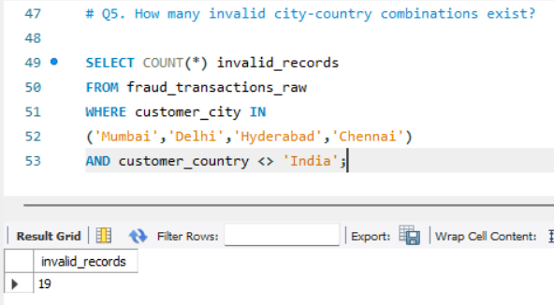
Insight
19 records showed mismatched city-country combinations.
Recommendation
- Implement location validation rules.
- Flag records with inconsistent geography for review.

B. Customer Analysis
Q6. Unique Customers & Accounts
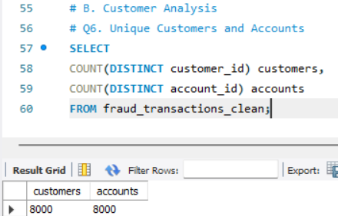
Insight
8,000 customers and 8,000 accounts indicate a one-to-one customer-account relationship.
Recommendation
- Develop customer-level risk profiles.
- Monitor high-value individual customers.

Q7. Age Distribution
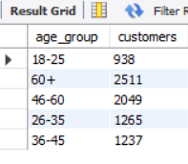
Insight
The 60+ age group represents the largest customer segment.
Recommendation
- Enhance fraud awareness for senior customers.
- Create additional authentication controls for vulnerable groups.

Q8. Transaction Volume by Segment
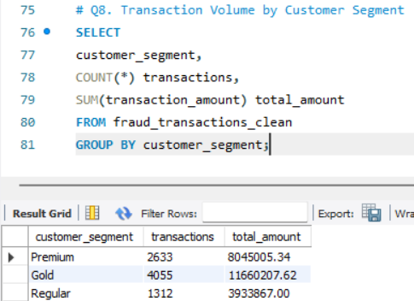
Insight
Gold customers generate the highest transaction volume and value.
Recommendation
- Prioritize Gold and Premium customers for retention.
- Deploy advanced fraud monitoring for high-value segments.

Q9. Highest Account Balances
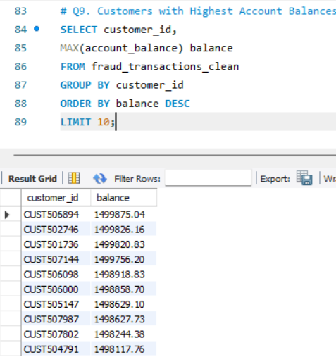
Insight
Top customers maintain balances close to ₹15 lakh.
Recommendation
- Introduce VIP customer monitoring.
- Apply enhanced fraud alerts for high-balance accounts.

Q10. Average Tenure
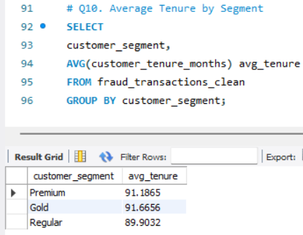
Insight
Average customer tenure is approximately 90 months across all segments, indicating a mature customer base.
Recommendation
- Use tenure as a risk-adjustment factor.
- Long-tenure customers generally require lower fraud risk weighting.

C. Transaction Analysis
Q11. Total Transaction Value
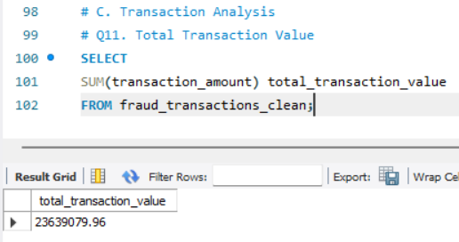
Insight
The bank processed approximately ₹2.36 Crore in transaction value.
Recommendation
- Monitor transaction value growth monthly.
- Establish anomaly detection for sudden spikes.

Q12. Average Transaction Amount
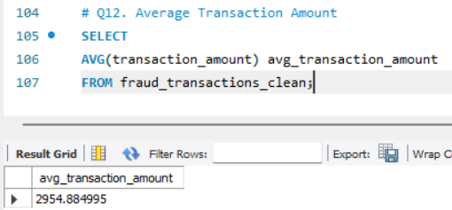
Insight
Average transaction value is approximately ₹2,955.
Recommendation
- Use this as a benchmark for anomaly detection.
- Flag transactions significantly above average.

Q13. Transaction Category Distribution
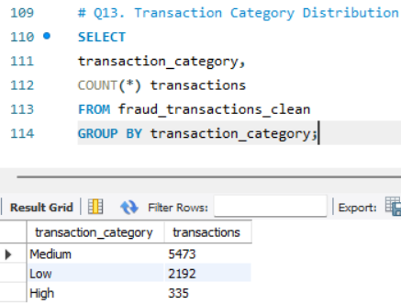

Insight
Medium-value transactions dominate the portfolio.
Recommendation
- Focus fraud models on medium-value transactions due to volume concentration.

Q14. Peak Transaction Hours
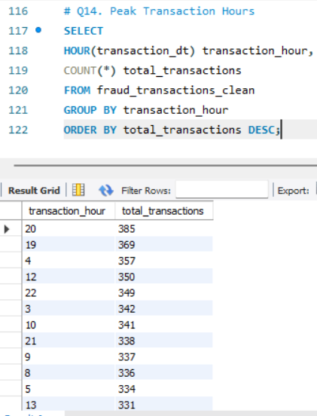
Insight
Transaction activity peaks around 7 PM–10 PM.
Recommendation
- Increase fraud monitoring during peak transaction periods.
- Allocate operational support resources accordingly.

Q15. International Transaction Percentage
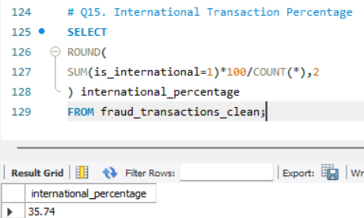

Insight
35.74% of transactions are international.
Recommendation
- Maintain enhanced monitoring for cross-border payments.
- Apply geo-location verification.

D. Payment Channel Analysis
Q16. Most Used Payment Channel
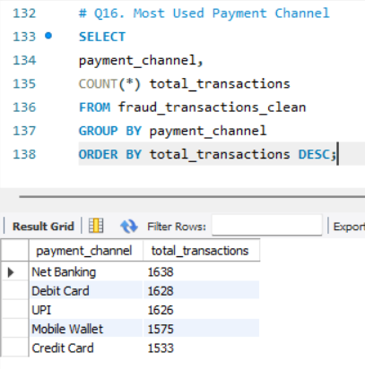
Insight
Net Banking is the most frequently used payment method.
Recommendation
- Prioritize Net Banking platform reliability and security.

Q17. Highest Transaction Value Channel
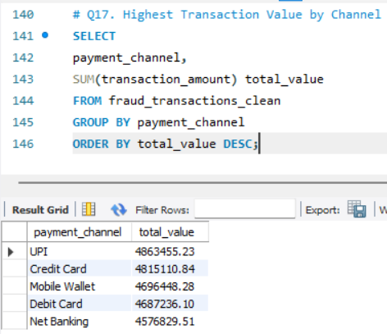
Insight
UPI generates the highest transaction value.
Recommendation
- Strengthen UPI fraud controls.
- Monitor unusual transaction velocity.

Q18. Risk Score by Payment Channel
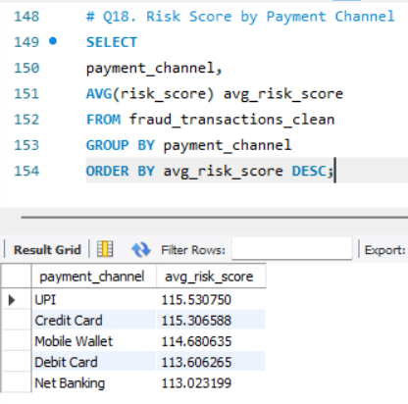
Insight
UPI has the highest average risk score.
Recommendation
- Implement stricter UPI fraud rules.
- Monitor new-device UPI transactions.

Q19. Average Transaction Amount by Channel
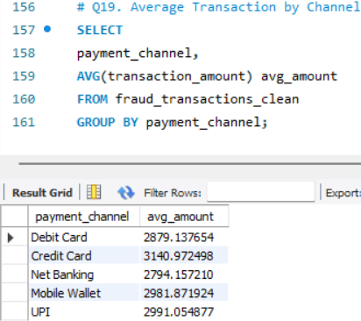
Insight
Credit Cards show the highest average transaction size.
Recommendation
- Monitor high-ticket credit card purchases.
- Deploy spending pattern analytics.

Q20. Failed Transactions by Channel
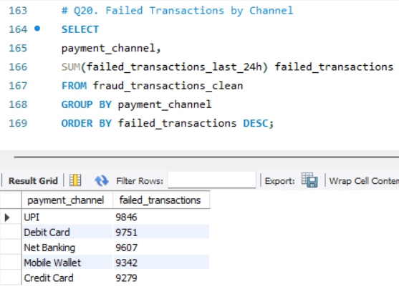
Insight
UPI records the highest failed transaction count.
Recommendation
- Investigate failed UPI transaction causes.
- Monitor repeated failure patterns as fraud indicators.

E. Merchant Analysis
Q21. Top Merchants
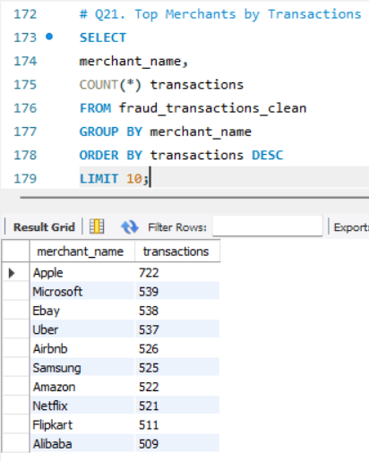
Insight
Apple, Microsoft, and eBay are among the highest transaction-volume merchants.
Recommendation
- Create merchant-specific fraud thresholds.
- Monitor high-volume merchants continuously.

Q22. Top Merchant Revenue
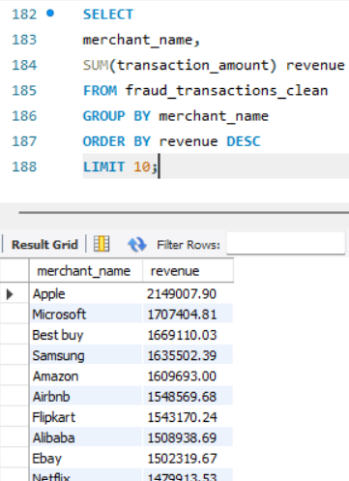
Insight
Apple contributes the highest transaction revenue.
Recommendation
- Develop strategic merchant partnerships.
- Monitor revenue concentration risk.

Q23. Merchant Category Contribution
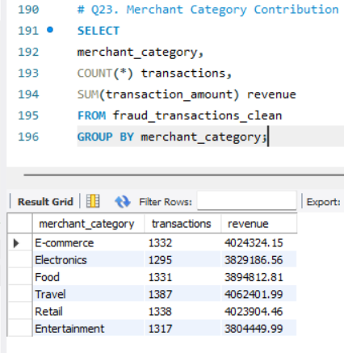

Insight
Travel and Retail categories generate the highest revenue.
Recommendation
- Apply category-based fraud models.
- Increase monitoring of high-value sectors.

Q24. Highest Average Transaction Merchant
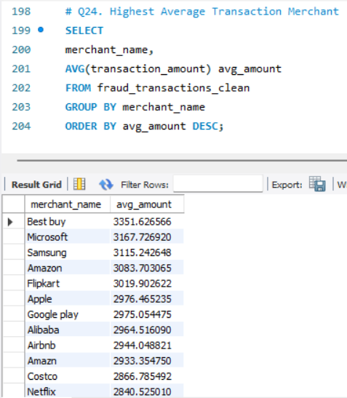
Insight
Best Buy has the highest average transaction amount.
Recommendation
- Flag unusually large purchases within high-value merchants.

Q25. High-Risk Merchant Categories
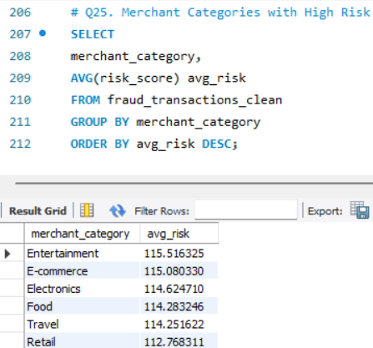
Insight
Entertainment and E-commerce categories exhibit the highest average risk scores.
Recommendation
- Introduce category-based fraud scoring.
- Monitor digital goods and subscription transactions.

F. Device Analysis
Q26. Device Usage Distribution
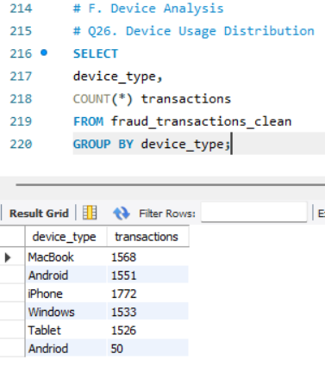
Insight
iPhone users generate the highest transaction count.
Recommendation
- Tailor fraud detection by device type.
- Standardize device naming to remove Android/Andriod duplicates.

Q27. New Device Usage
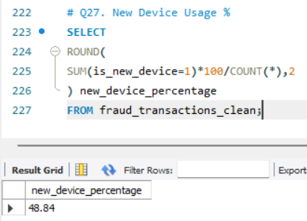
Insight
48.84% of transactions originate from new devices.
Recommendation
- Require step-up authentication for new devices.
- Trigger OTP verification.

Q28. Device-wise Transaction Value
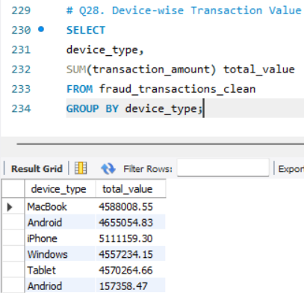
Insight
iPhone users contribute the highest transaction value.
Recommendation
- Monitor high-value mobile transactions.

Q29. Risk Score by Device
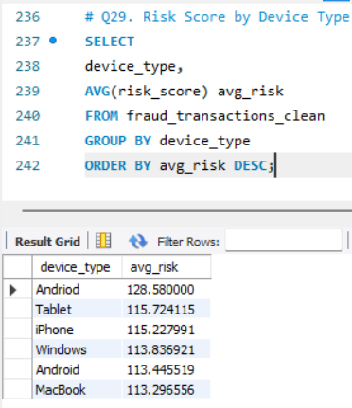
Insight
The misspelled Android category ("Andriod") has the highest risk score, indicating a data-quality issue and potentially suspicious activity.
Recommendation
- Standardize device values.
- Investigate high-risk Android-origin transactions.

Q30. Failed Transactions by Device
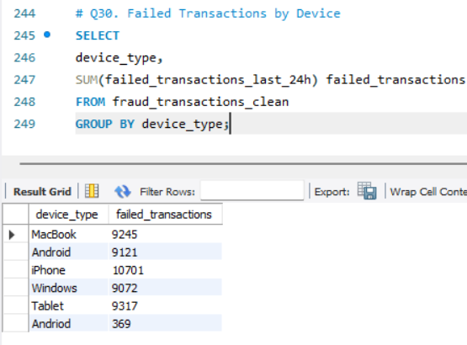
Insight
iPhone devices generate the highest failed transaction count.
Recommendation
- Investigate device-specific authentication failures.

G. Geographic Analysis
Q31. Top Cities
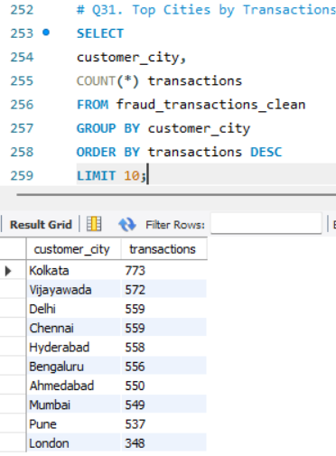
Insight
Kolkata contributes the highest transaction volume.
Recommendation
- Create city-level fraud monitoring dashboards.

Q32. Top Countries by Transaction Value
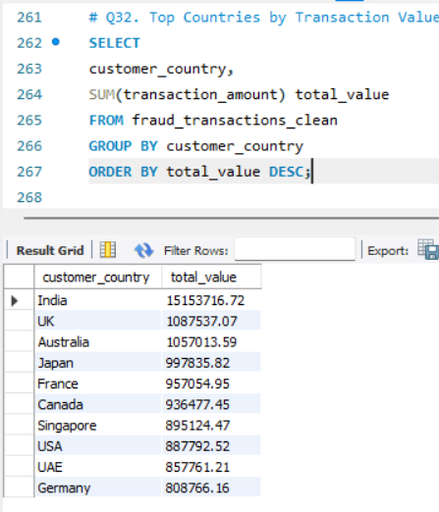
Insight
India contributes the highest transaction value.
Recommendation
- Maintain domestic monitoring while increasing focus on high-value international markets.

Q33. Domestic vs International
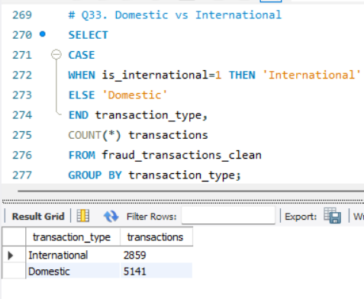
Insight
Domestic transactions account for 64% of all activity.
Recommendation
- Apply different fraud thresholds for domestic and international transactions.

Q34. Highest Average Transaction Cities
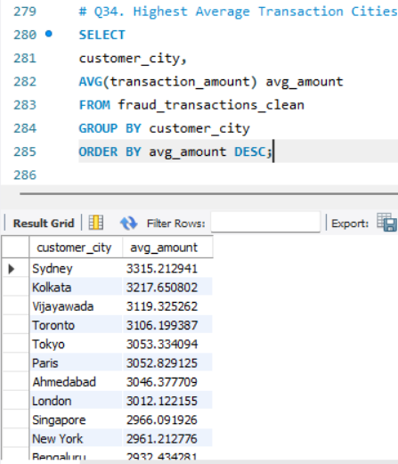

Insight
Sydney records the highest average transaction amount.
Recommendation
- Monitor high-value international transactions.

Q35. India vs International Comparison
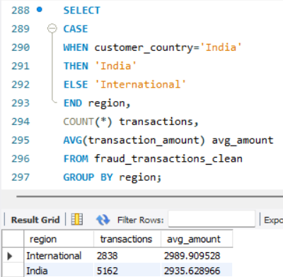
Insight
International transactions show slightly higher average transaction values than Indian transactions.
Recommendation
- Introduce enhanced controls for international spending behavior.

H. Fraud Risk & Behavioral Analysis
Q36. Highest Risk Customers
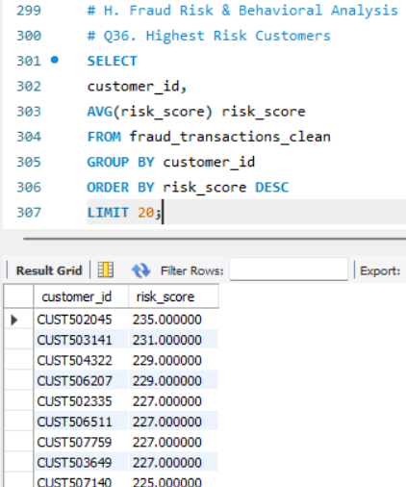
Insight
Several customers exceed risk scores of 225+, making them priority investigation candidates.
Recommendation
- Establish customer watchlists.
- Conduct enhanced due diligence.

Q37. Transaction Frequency vs Risk
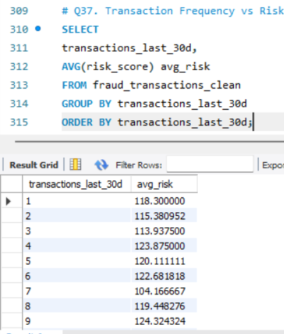
Insight
Higher transaction frequency generally corresponds with elevated risk levels.
Recommendation
- Create velocity-based fraud rules.
- Flag abnormal transaction bursts.

Q38. Failed Transactions vs Risk
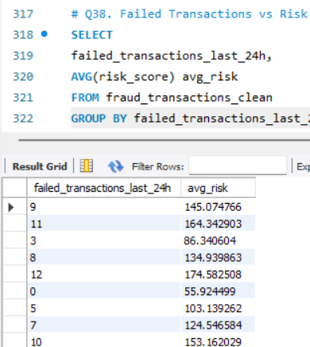
Insight
Frequent failed transactions are strong indicators of fraud attempts.
Recommendation
- Trigger temporary account restrictions after repeated failures.

Q39. International vs Domestic Risk
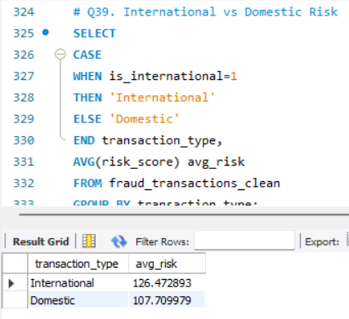
Insight
International transactions exhibit higher fraud exposure compared to domestic transactions.
Recommendation
- Apply stronger authentication and geo-verification for international activity.

Q40. Highest Fraud-Risk Pattern
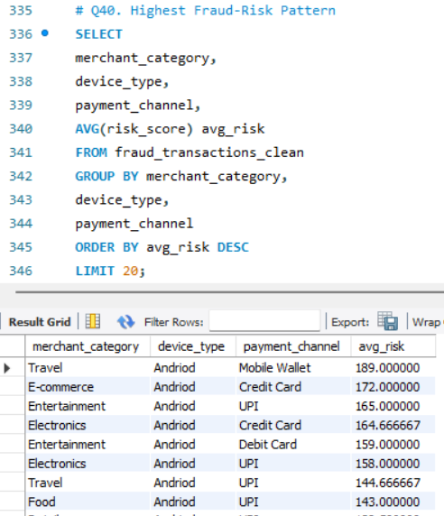
Insight
The highest-risk pattern involves:
- Travel & Entertainment merchants
- Android devices
- Mobile Wallets and Credit Cards
These combinations produce the highest average risk scores.
Recommendation
- Create real-time fraud rules for these combinations.
- Trigger additional verification before transaction approval.
Final Business Conclusion
The analysis reveals that fraud exposure is concentrated around:
- International transactions
- New devices
- UPI and Mobile Wallet channels
- Entertainment, Travel, and E-commerce merchants
- High-frequency customer behavior
- Android-based transaction activity
The bank should prioritize risk-based authentication, transaction velocity monitoring, device fingerprinting, merchant risk scoring, and international transaction surveillance to reduce fraud losses while maintaining customer experience.

